Zello Standard Operating Procedure

The ZELLO app enables “walkie talkie” or radio functionality from any location with a network connection. It is therefore not limited by range like the older style PMR 446 Radios we used on events and it also totally secure in the same way as a phone call.
The app is “Push to Talk” meaning that you push and hold a button either on the screen or physical to transmit and then release when you have finished talking
It allows person to person chat as well as chat in an open forum.
The standard group chat is called: 01 – XT Driver Training
The password to join the group is: xtdriving
You can also talk directly to any other Contact “point to point”

Legality:
As long as you not physically holding the phone (i.e. it’s a holder or on a magnetic holder) then pushing the zello button to talk is completely legal however also consider the public perception if you are doing this clearly in view. There is no suggestion that you use this app for communication while on a lesson however you may want to use an ear piece to monitor any calls or example warnings of roadworks/congestion etc.
You can also use one of the Bluetooth devices, ie:
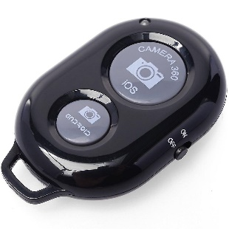
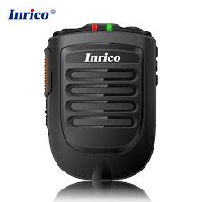
Which are also completely legal to hold.
Note transmission on zello will come immediately though your phone speaker/Bluetooth device if its connected to your car, so ensure you are signed out or muted if you have a car set installed or a customer present.
Car sets such as the TM7 are also available:
